**INTERNATIONAL INSTITITE OF PROFESSIONAL STUDIES**

**DEVI AHILYA VISHWAVIDYALAYA**

**INDORE (M.P)**

**2019-2020**

Project Report

On

**“DFM WEB APP”**

A Project Report Submitted for the Partial Fulfillment of 3rd year of

Master of Computer Application (6 Yrs.)

Submitted To-: Submitted By-:

Dr. Rahul Singhai Aakash Wankhede (IC-2K17-49)

Anup Singh (IC-2K17-55)

Himank Shah (IC-2K17-62)

**INTERNATIONAL INSTITITE OF PROFESSIONAL STUDIES**

**DEVI AHILYA VISHWAVIDYALAYA**

**INDORE (M.P)**



**2019-2020**

A Final Project Report On.

**“DFM WEB APP”**

A Project Report Submitted In Partial Fulfillment of Requirements of Minor Project In 6th semester.

Submitted To-: Submitted By-:

Dr. Rahul Singhai Aakash Wankhede (IC-2K17-49)

Anup Singh (IC-2K17-55)

Himank Shah (IC-2K17-62)

**DECLAREATION**

I hereby declare that the project work entitled **“DFM WEB APP”** submitted to the I.I.P.S D.A.V.V INDORE, is a record of an original work done by us under the guidance of  **Dr. Rahul Singhai,** Master Of Computer Applications, International Institute of Professional Studies DAVV Indore , and this project work is submitted in the partial fulfillment of their requirements for the award of the degree of Master of Computer Applications. The results embodied in this thesis have not been submitted to any other University or Institute for the award of any degree or diploma.

We have completed this project work during VIth Semester session (2019-2020).

Signature of Student.

Aakash Wankhede - _____________

Anup Singh - _______________

Himank Shah - ______________

Date - ______________

Place - ______________

**CERTIFICATE**

This is to be certified that Himank Shah, Anup Singh, Akash Wankhede students of IIIrd Year M.C.A., VIth semester of Master of Computer Application Department, International Institute of Professional Studies, Devi Ahilya Vishwavidyalaya, Indore (M.P.) have completed their Minor Project entitled

**“DFM WEB APP”**

They have submitted their Project Report for the partial fulfillment of the curriculum of the Degree of Master of Computer Applications (6 years), International Institute of Professional Studies, Devi Ahilya Vishwavidyalaya.

Project Guide

Signature-: _____________

Name-: Dr. Rahul Singhai

Date-: _____________

**CERTIFICATE**

This is to be certified that Himank Shah ,Anup Singh students of II Year M.C.A., VIth semester of Master of Computer Application Department, International Institute of Professional Studies, Devi Ahilya Vishwavidyalaya, Indore(M.P.) and hereby accord our approval of it as a study carried out and presented in a manner required for its acceptance in the partial fulfillment for the award of the degree of “Master of Computer Application(6 Years)” VIth semester.

Internal Examiner External Examiner

Signature-: ___________ Signature: ___________

Name-: ______________ Name-: ______________

Date-: ______________ Date-: ______________

**ACKNOWLEDEGEMENT**

We acknowledge my sincere thanks to those who have contributed significantly to this project. It is a pleasure to extend deep gratitude to our internal guide Dr. Rahul Singhai, International Institute of Professional Studies, for their valuable guidance and support and to continuously prompt us for the progress of the report.

We thank them for their valuable suggestion towards our project, which helped us in making this project more efficient and user friendly.

We thank and acknowledge each and every one’s effort that helped me in some or the other way for small and significant things.

**ABSTRACT**

This is a website which helps customer to find and buy all types of furniture on internet. It is useful in the way that it makes an easier way to buy furniture online. DFM in an interactive e-commerce solution providing users with an opportunity to buy furniture. DFM is online platform which deals with latest and fascinate furniture.

In this website we have basically 2 modules. The first module includes the customer and second includes admin module.

The customer has to register or signed up for buying furniture and enquiry related to furniture. The registered customer can only place orders. But the non-registered customer cannot buy or place orders. Every user can view the products and items in details.

The admin module contains the access of the admin page on the website. This admin module has mainly two work. Firstly, the admin can maintain and update the stock and confirm the orders and secondly the shipping department which is tracking and maintaining the orders at different stages.

Table of Contents

Title Page No.

1.Introduction 01

1.1 Background Problem 01

1.2 Purpose 02

1.3 Scope 02

1.4 Methodology 02

2. Aims & Objectives 03

2.1 Aims 03

2.2 Objectives 03

3. Software Development Life Cycle 04

3.1 Feasibility Study 05

3.1.1 Economical Feasibility 05

3.1.2 Technical Feasibility 05

3.2 Data Flow Diagram 05

3.3 Analysis 07

3.3.1 Existing System 08

3.3.2 Proposed System 08

3.4 Planning 09

3.4.1 Specific Requirements 09

3.4.2 Hardware Requirements 09

3.4.3 Software Requirements 10

3.4.4 Other Requirements 10

3.5 Design 10

3.5.1 Entity definition 10

3.5.2 Attribute definition 11

3.5.3 Relationships 11

* + 1. E-R Diagram 12

3.5.5 Flow diagram 13

3.6 Implementation 14

3.7 Testing 15

3.7.1 Unit Testing 15

3.7.2 Integration Testing 16

3.7.3 Validation Testing 16

4. Study of System 17

4.1 Administrator 17

4.2 Users 18

4.3 Shipping Department 19

5.ScreenShots 20

6.Future Scope of App 25

7. Conclusion 26

8. Bibliography and Reference 27

8.1 Bibliography 27

8.2 Reference 27

**Introduction**

E-commerce is fast gaining ground as an accepted and used business paradigm. More and more business houses are implementing web sites providing functionality for performing commercial transactions over the web. It is reasonable to say that the process of shopping on the web is becoming commonplace.

The objective of this project is to develop a general-purpose e-commerce store where product like furniture can be bought from the comfort of home through the Internet. However, for implementation purposes, this paper will deal with an online shopping for furniture.

An online store is a virtual store on the Internet where customers can browse the catalog and select products of interest. The selected items may be collected in a shopping cart. At checkout time, the items in the shopping cart will be presented as an order. At that time, more information will be needed to complete the transaction. Usually, the customer will be asked to fill or select a billing address, a shipping address, a shipping option, and payment information such as credit card number.

1.1 Background problem

India is a developing country and Information Communication and technology are playing their important roles in the development of the country. By E-commerce, we mean buying and selling of products or services over electronic systems such as the Internet and other computer networks. In truth in India, we have very fewer ways to pay our bills online or trade online. But that does not mean we cannot. There are new players on Indian ground like Bill-Desk and SBI E-pay who want to revolutionize the way the Indian eCommerce field is taken.

With the launch of these services (DFM), many new startups can easily sell their products and services online. These services have lots of potentials and we hope it will succeed and bring a change in the Indian eCommerce field.

1.2 Purpose

This web application is developed for the users / customer who want to buy the quality furniture for the home only. This web app will help the people to buy the easy, fast delivery and superior quality of furniture goods to their door.

1.3 Scope

* Selling can be centred around the Global client.
* Pre-deals, subcontracts, and supply.
* Financing and protection.
* Commercial exchanges, requesting, conveyance instalment.
* Product administration and support.
* Cooperative item improvement.
* Distributive co-employable working.
* Use of open and private administrations.
* Business to organization (client).
* Transport and coordination’s.
* Public acquisition.
* Automatic exchanging of computerized merchandise.

1.4 Methodology

A methodology is a model, which is employed for the design, planning, implementation and achievement of the project objectives. Methodology has many research dimension and methods. Methodology is the underlying principles and rules that govern system method, on the other hand it is a systematic procedure for a set of activities. We have used the php, which is server site scripting language and apache’s xampp server with MySQL database where data is stored that lets you quickly and easily develop mobile and web application, as well as HTML5 applications with HTML, JavaScript and CSS.

**Aims & Objectives**

2.1 Aims

* To develop the business and promote the cheap & better-quality furniture.
* To protect and promote the interest of trade, commerce and furniture industry.
* To unite people engaged in trade, commerce and furniture industry for concerted action to protect and promote their common interests.
* To take interest in and formulates its view matters directly or indirectly affecting the business community.

2.2 Objectives

The main objective to develop the DFM web app is to promote and establish the branding and the name of the DFM in to the ecommerce platform. To maximize the profit and to get the fame and name in the market. Some of the other major objectives are: -

* Reduce Management Costs.
* Developing Business Relation.
* Providing a unique Customer experience.
* Increasing the number of loyal Customer.
* Boosting the efficiency of services.
* Developing Relevant Target.

**Systems Development Life Cycle**

**(SDLC)**

System Development Life Cycle is a conceptual model used in software development projects. In this method, there is a possibility of combining two or more project management methodologies for the best outcome. Therefore, we have used waterfall Model along with SDLC. SDLC also heavily emphasizes on the use of documentation and has strict guidelines on it.

**Waterfall Model**

This is the legacy model for software development projects. This methodology has been in practice for decades before the new methodologies were introduced. In this model, development life cycle has fixed phases and linear timelines. The Waterfall Model is a sequential software development process, on which progress is seen as steadily downwards (like waterfall) through phases of requirement, design, implementation, verification and maintenance.

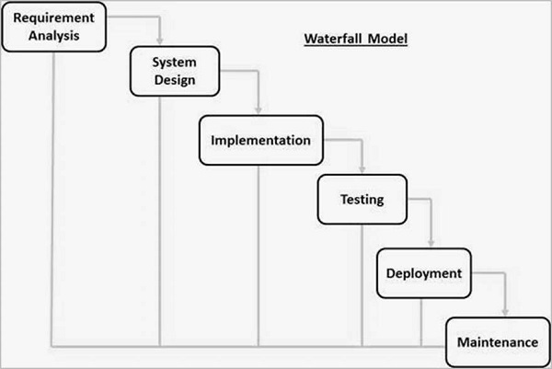

Fig 3.0 Waterfall Model

3.1 Feasibility Study

Feasibility is a measure of how beneficial the development of the information system will be to an organization. This is done by investigating the existing system in the area under investigation or generally ideas about a new system. It is a test of a system proposal according to its workability, impact on the organization, ability to meet user needs, and effective use of resources.

3.1.1 Economic Feasibility

Economic analysis is the most frequently used method for evaluating the effectiveness of a proposed system. It is more commonly known as cost benefit analysis, the procedure to determine the benefits and saving that are expected from a candidate system and compare them with costs. If the benefits outweigh costs then a decision is made to design and implement the system. Otherwise make alterations in the proposed system.

The creation of website is very helpful to the business and much economical for the business. Manual system is highly cost driven due to high labor costs. If the user uses the DFM Web App to buy the products it will be cost-effective. Thys the system is economically feasible.

3.1.2 Technical Feasibility

In examining Technical feasibility of the system, more importance is given to the hardware interaction part of the system. The assessments of technical feasibility centers on the existing system and to what extent it can support the proposed addition. Only the requirement of the speedy internet connection like broadband is required.

3.2 Data Flow Diagram

A data flow diagram (DFD) is a graphical representation of the "flow" of data through an information system, modeling its process aspects. A DFD is often used as a preliminary step to create an overview of the system without going into great detail, DFDs can also be used for the visualization of data processing (structured design).

A DFD shows what kind of information will be input to and output from the system, how the data will advance through the system and where the data will be stored.

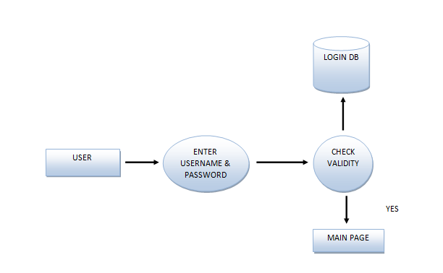

Fig 3.2.1 DFD User Login

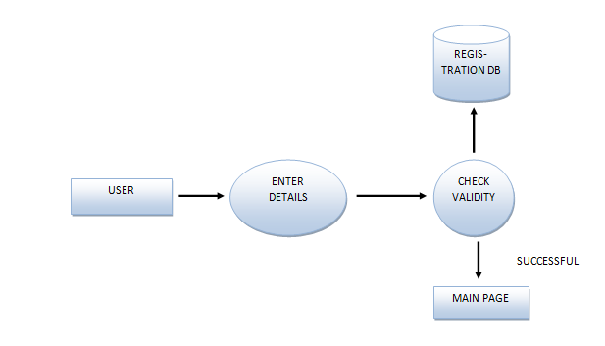

Fig 3.2.2 DFD User SignUp

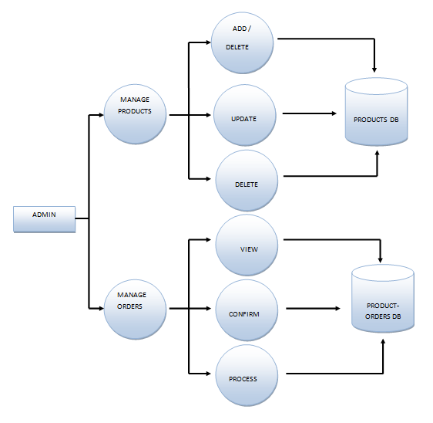

Fig 3.2.3 DFD Admin

3.3 Analysis

System analysis is the process of gathering and interpreting facts, diagnosing problems and using the information to recommend improvements on the system. System analysis is a problem-solving activity that requires intensive communication between the system users and system developers. System analysis or study is an important phase of any system development process.

The system is viewed as a whole, the inputs are identified and the system is subjected to close study to identify the problem areas. The solutions are given as a proposal. The proposal is reviewed on user request and suitable changes are made. This loop ends as soon as the user is satisfied with the proposal.

3.3.1 Existing System

The current system for shopping is to visit the shop manually and from the available product choose the item customer want and buying the item by payment of the price of the item.

* It is less user-friendly.
* User must go to shop and select products.
* It is difficult to identify the required product.
* Description of the product limited.
* It is a time-consuming process
* Not in reach of distant users.

3.3.2 Proposed System

In the proposed system customer need not go to the shop for buying the products. He can order the product he wish to buy through the application in his Smartphone. The shop owner will be admin of the system. Once the order is placed by the customer and confirmed by the admin it will go for the further processing to shipping department to deliver the product.

3.4 PLANNING

Planning is the process of thinking about the activities required to achieve a desired goal. Planning involves the creation and maintenance of a plan, such as psychological aspects that require conceptual skills. There are even a couple of tests to measure someone’s capability of planning well.

We have planned our interface in a such that the user can get easily and everything on the UI. Here user can search and buy the furniture easily. It is designed for the small as well as the large screen.

3.4.1Specific Requirements

Since the Administrator and the user are the main target group of our software, we will only concern about some important functions for the admin and the user.

Administrator-:

* Admin is one who manipulate and maintains the app and orders.
* Admin who is only able to Add, Delete or Modify the products.
* Admin is only one who is confirming orders.
* Shipping department also works under admin.

Users-:

* User can search web app on internet.
* User have to register for buying furniture.
* User can buy variety products from it.
* User can see their orders and personal details also.

3.4.2 Hardware Requirements

* CPU: Intel 1.6 Ghz
* RAM: 2 Gb

3.4.3 Software Requirements

* Operating System: Windows OS
* Front End: HTML, CSS
* Back End: JavaScript, PHP
* Web Server: Apache XAMPP
* Browser: Chrome

3.4.4 Other Requirements

* System should be able handle multiple users.
* Database updating should follow transaction processing to avoid data

inconsistency.

* The system requires internet connectivity for loading resources.

3.5 Design

Design phase is the creation of a plan or convention for the construction of an object, system or measurable human interaction. We have designed our application with a main page and connected it to the secondary pages which will fetch data from database (MySQL).

3.5.1 Entity definition

Entity are the principle data object about which information is to be collected. Entities are either concrete or abstract such as a person, place, things or event which have relevant to database.

3.5.2 Attribute definition

The attribute that are identified as part of the entities are listed along with their descriptions, data types and attribute name.

3.5.3 Relationships

* One –to –one
* One –to –many
* Many –to –many

3.5.4 E-R Diagram

An entity relationship model, also called an entity - relationship (ER) diagram, is a graphical representation of entities and their relationships to each other, typically used in computing in regard to the organization of data within databases or information state. An entity is a piece of data - an object or concept about which data is stored.

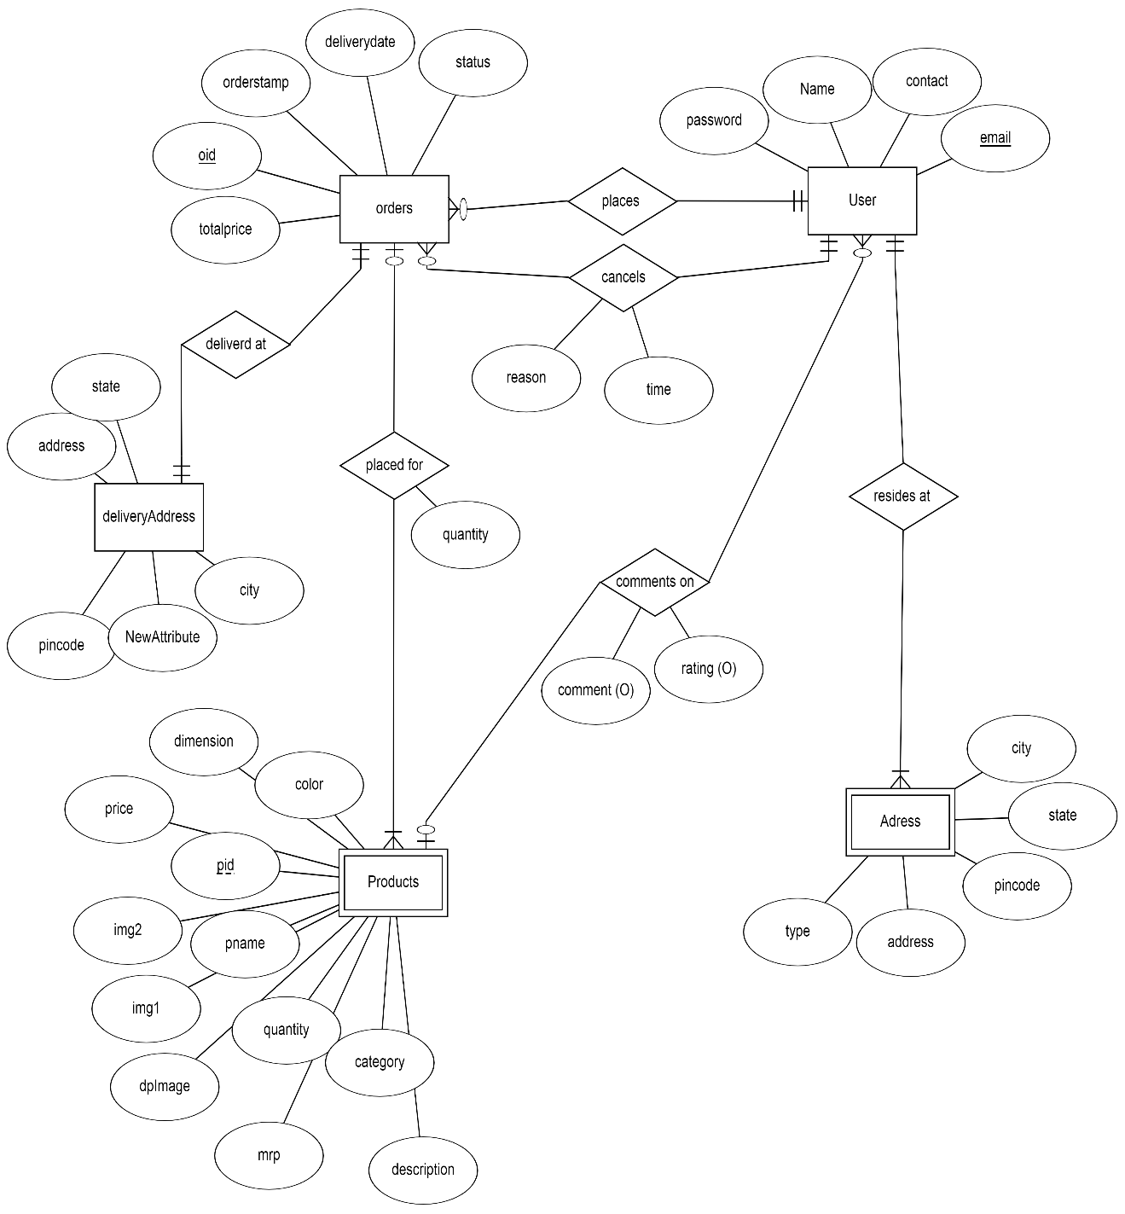

Fig 3.5.4 Entity-Relationship Diagram

3.5.5 FLOW CHART

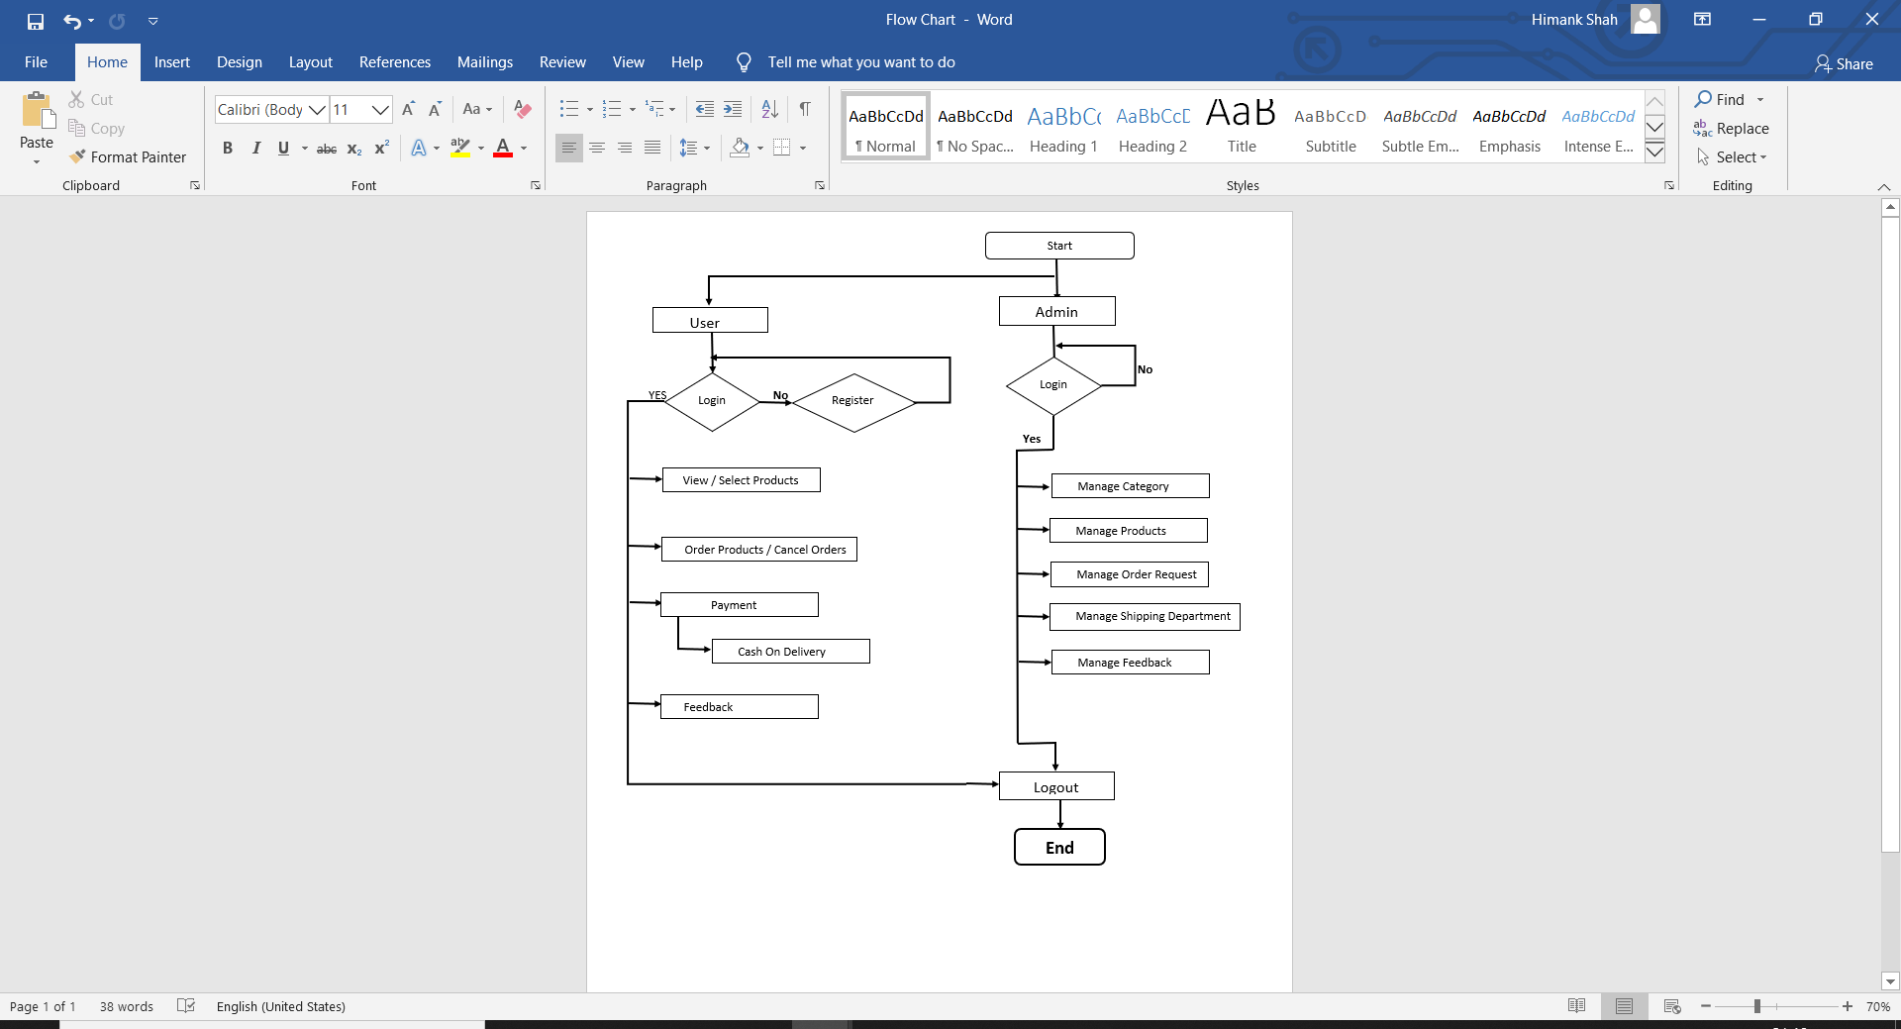

Fig 3.5.5 Flow Chart

3.6 Implementation

Implementation is the stage in the project where the theoretical design is turned into a working system and is giving confidence on the new system for the users that it will work efficiently and effectively .It involves careful planning, investigation of the current system and it's constraints on implementation , design of methods to achieve the changeover ,an evaluation , of changeover methods . Apart from planning major task of preparing the implementation are education and training of users. The more complex system being implemented, the more involved will be the system analysis and the design effort required just for implementation.

An implementation co-ordination committee based on policies of individual organization has been appointed. The implementation process begins with preparing a plan for the implementation of the system.

According to this plan, the activities are to be carried out, discussions are made regarding the equipment and resources and the additional equipment has to be acquired to implement the new system.

Implementation is the final and important phase. This is the most critical stage in achieving a successful new system and in giving the users confidence that the new system will work is effective.

The system can be implemented only after thorough testing. This method also offers the greatest security since the old system can takeover if the errors are found or inability to handle certain type of transactions while using the new system.

3.7 Testing

System testing is the stage of implementation, which is aimed at ensuring that the system works accurately and efficiently before live operation commences. Testing is vital to the success of the system. Testing is the process of executing a program with the explicit intention of finding errors that is making the program fail. The tester may analysts, programmer or a specialist trained for software testing, is actually trying to make the program fail. Analysts know that an effective testing program does not guarantee system reliability. Therefore, reliability must be designed into the system. Testing brings all the pieces together into a special testing environment, then checks for errors, bugs and interoperability.

3.7.1 Unit Testing

In unit testing we have to test the programs making up the system. For this reason, unit testing is sometimes called as the program testing. The software units in a system are modules and routines that are assembled and integrated to perform a specific function.

Unit testing focuses first on modules ,independently of one another , to locate errors .This enables ,to detect errors in coding and logic that are contained within the module alone .Unit testing can be performed from the bottom up ,starting with the lowest level modules and proceeding one at a time .Unit testing is done for each module in online test management tool. This ensures that the value we enter match with the data type and within the specified limit.

3.7.2 Integration Testing

Data can be lost across any interface ,one module can have an adverse effect on another ,sub functions when combined ,may not produce the desired major functions .Integration testing is a systematic testing for conducting tests to uncover errors associated within the interface .The objective is to take unit tested modules and build a program structure . All the modules are combined and tested as a whole.

Here correction is difficult because the vast expenses of the entire program complicate the isolation of causes. Thus, in the integration testing step, all the errors are corrected for the next testing steps. in online test management tool, each module is integrated and tested. This testing provides the assurance that the application is well integrated functional unit with smooth transition of data.

3.7.3 Validation Testing

At the culmination of integration testing, software is completely assembled as a package; interfacing errors have been recovered and corrected and a final series of a software tests - validation tests begin. Validation testing can be defined in many ways but a simple definition is that validation succeeds when the software functions in a manner that can be reasonably expected by the customer.

Invalidation testing if user wants to enter the numeric value, he can only enter the numeric value not the text value. For e.g.: in phone number field user can only enter numeric value to it. The system is user friendly with user guide and messages to explain further procedures. An attempt has been made to perfect the process by incorporating validation at each level.

**Study of System**

The system after careful analysis has been identified to be presented with the following modules and roles. The modules involved are:

* Administrator
* Users
* Shipping Department

4.1 Administrator

The administrator is the super user of this application. Only admin have access into this admin page. Admin is the owner of the shop. The administrator has all the information about all the users and about all products. The admin is only who can confirm the orders.

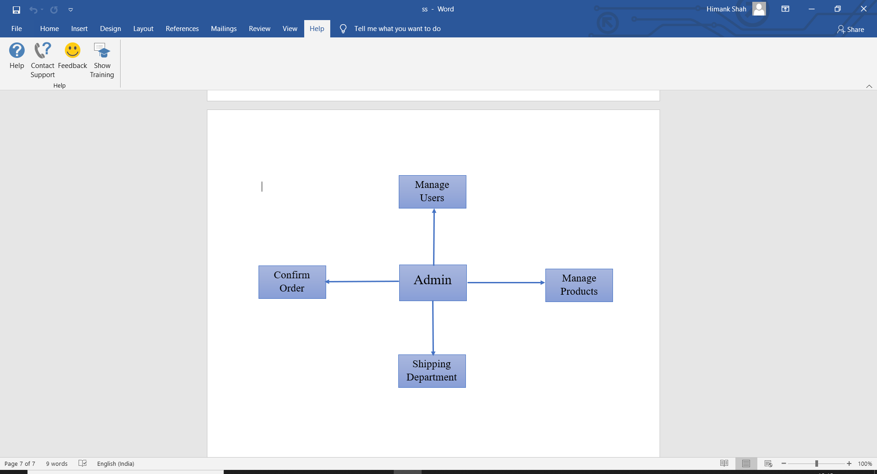

Fig 4.1 Admin Module

4.2 Users

A new user will have to register in the system by providing essential details in order to view the products in the system. The admin must accept a new user by unblocking him.

* **Login:** A user must login with his user name and password to the system after registration.
* **View Products:** User can view the list of products based on their names after successful login. A detailed description of a particular product with product name, products details, product image, price can be viewed by users.
* **Search Product:** Users can search for a particular product in the list by name.
* **Add to cart:** The user can add the desired product into his cart by clicking add to cart option on the product. He can view his cart by clicking on the cart button. All products added by cart can be viewed in the cart. User can remove an item from the cart by clicking remove.
* **Submit Cart:** After confirming the items in the cart the user can submit the cart by providing a delivery address. On successful submitting the cart will become empty.
* **My Orders**: In my orders user can a view of order details.
* **Edit Profile**: The user can view and edit the profile.

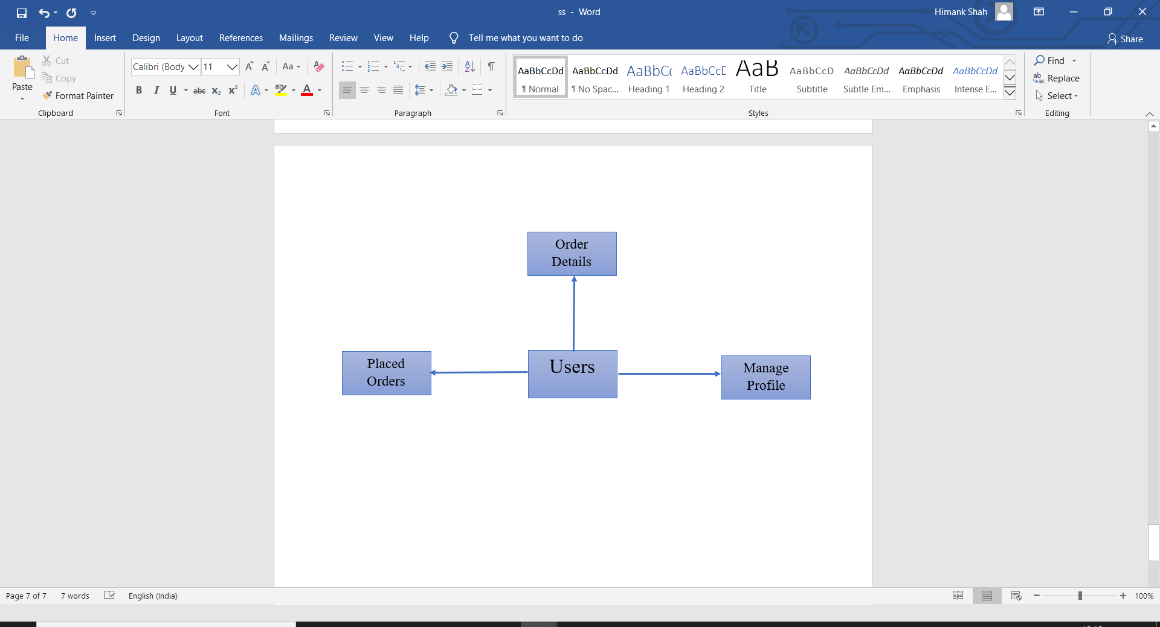

Fig 4.2 User Module

4.3 Shipping Department

After the order has been confirmed by the admin, for further processing of the orders it has been send to the shipping department who is responsible for the shipping, tracking and delivering the orders.

* **Cancelled:** The orders cancelled by the customer.
* **Shipping:** The confirm orders are shipped and tracked.
* **Delivered:** The shipped orders are delivered to customer.
* **Return:** The delivered orders are return by the customer.

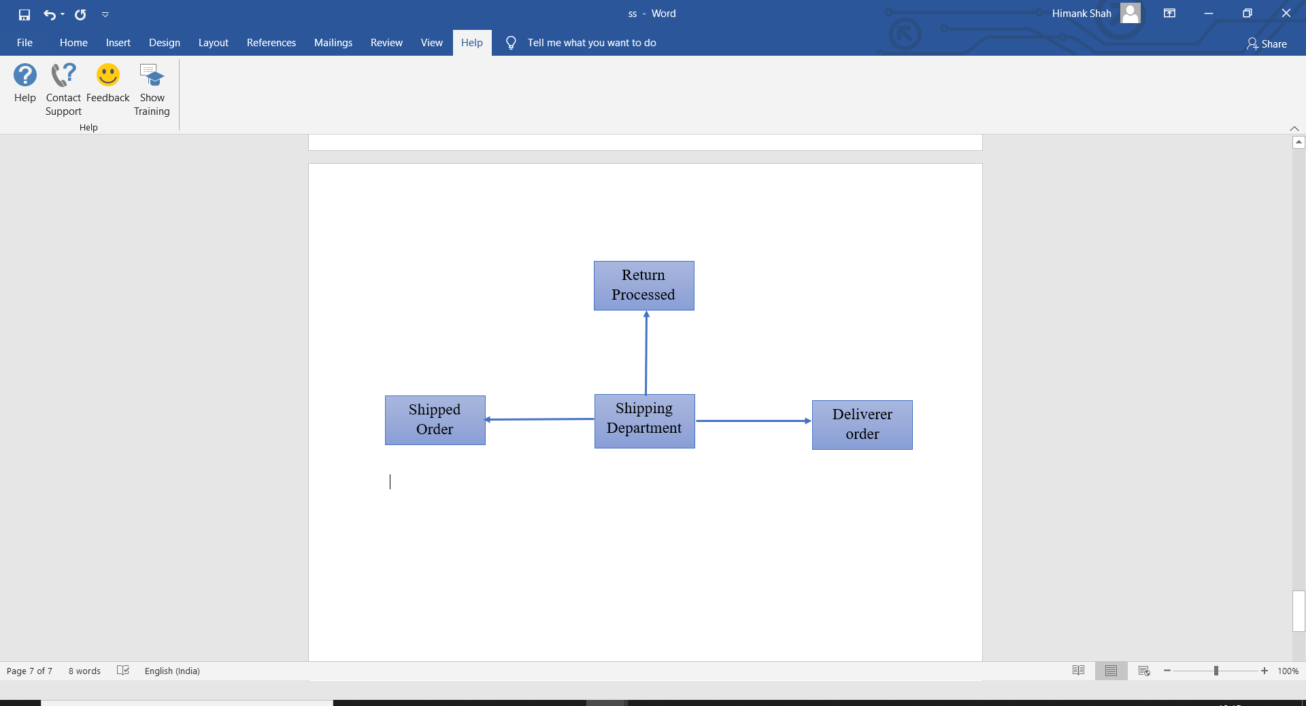

Fig 4.3 Shipping Module

**Screenshots**

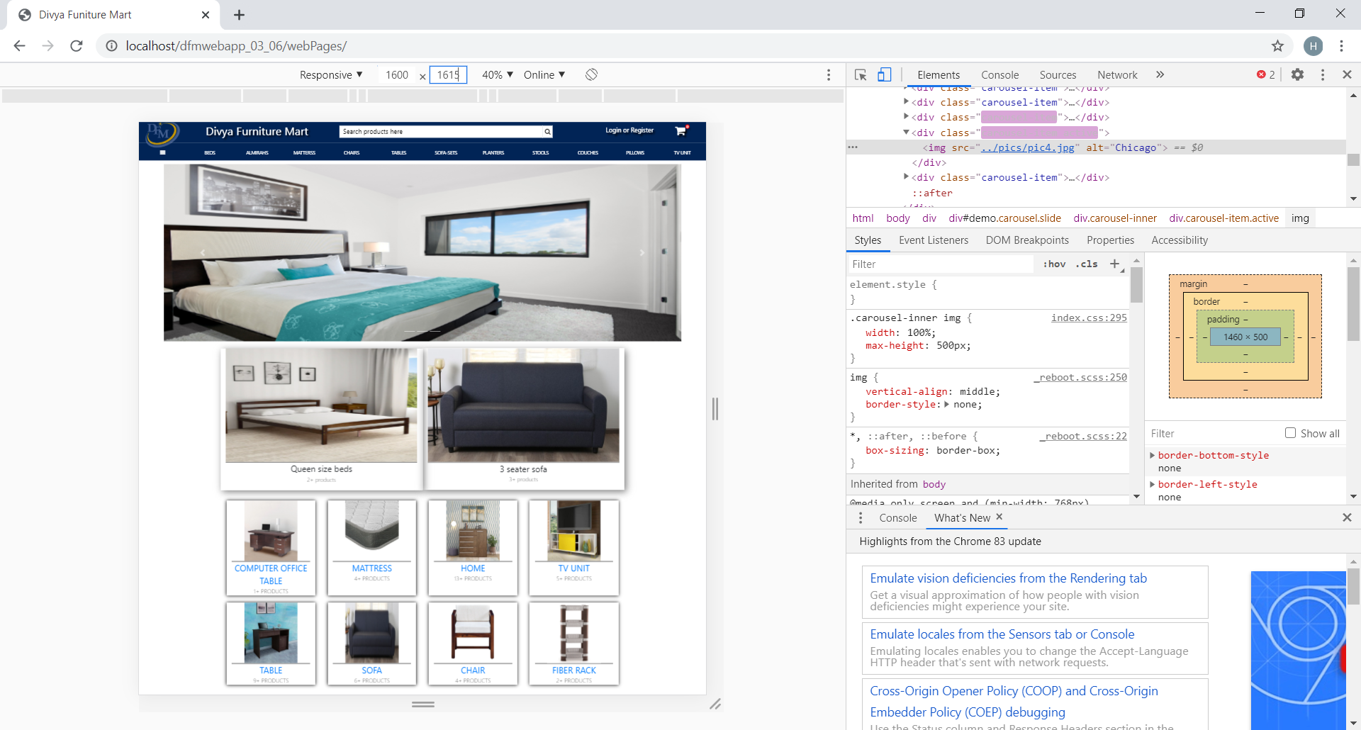

Fig 5.1.1 User Interface

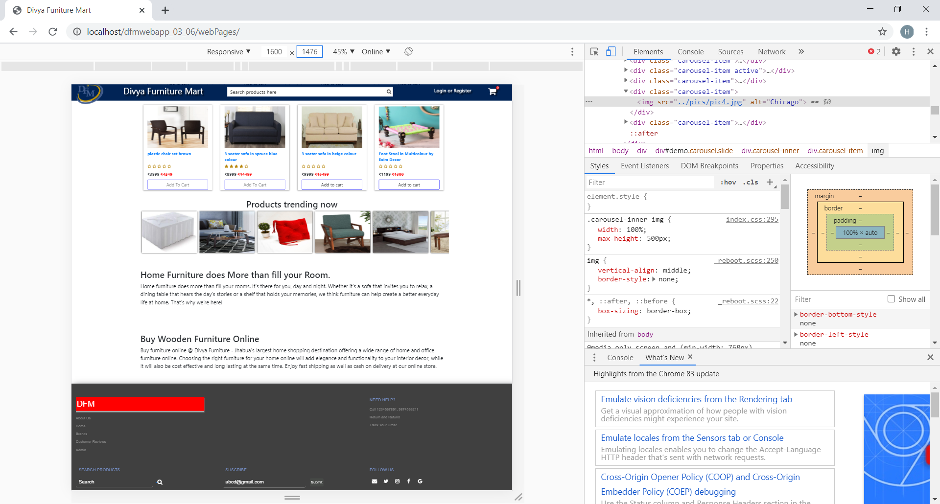

Fig 5.1.2 User Interface

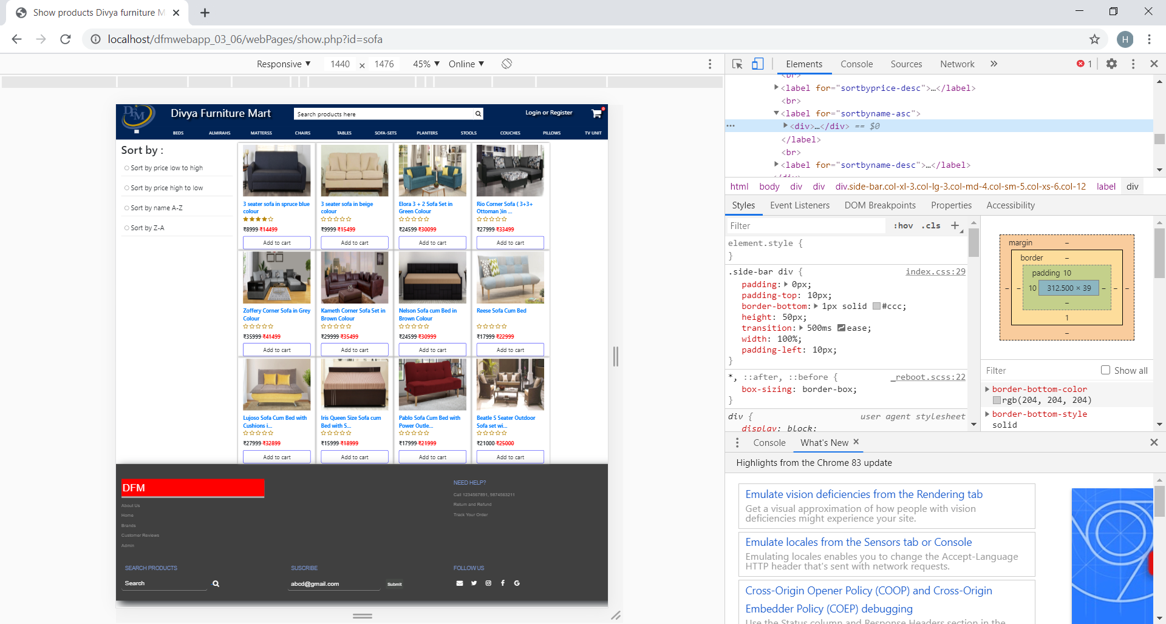Fig 5.2 Show Products

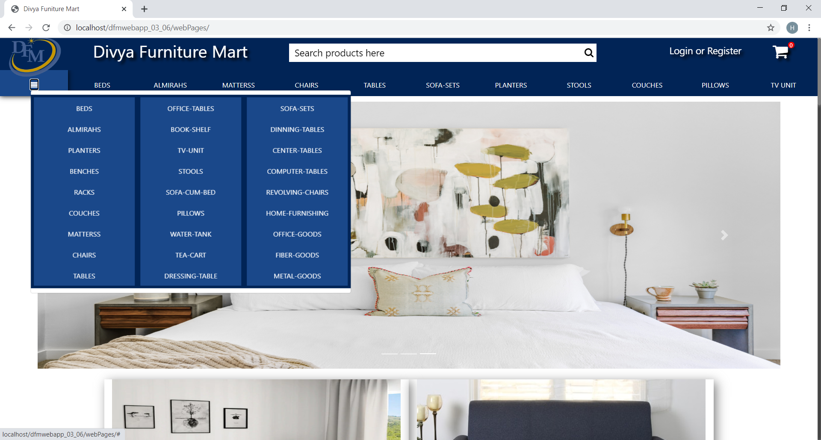

Fig 5.3 Categories

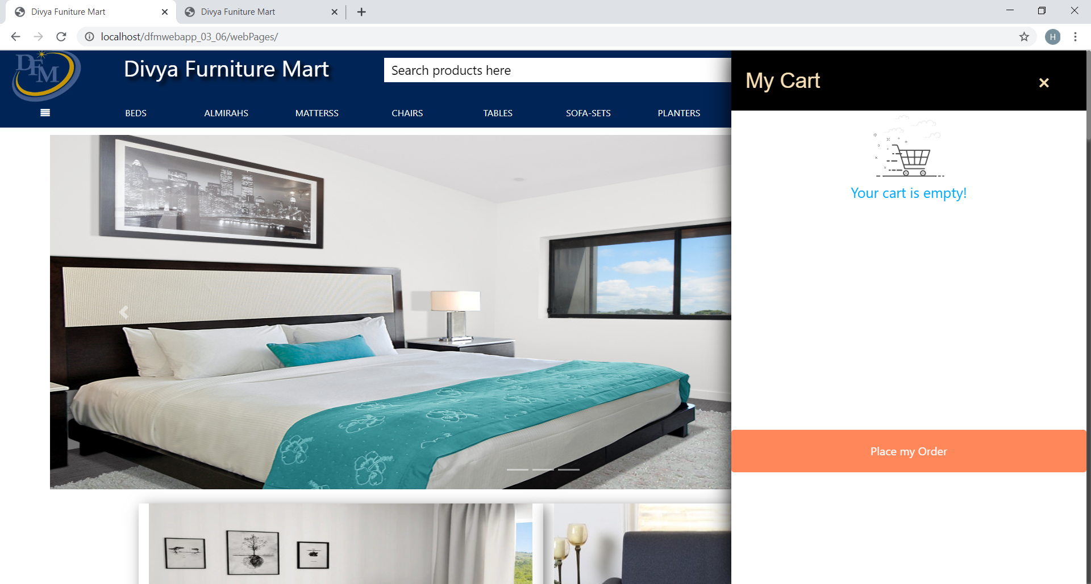 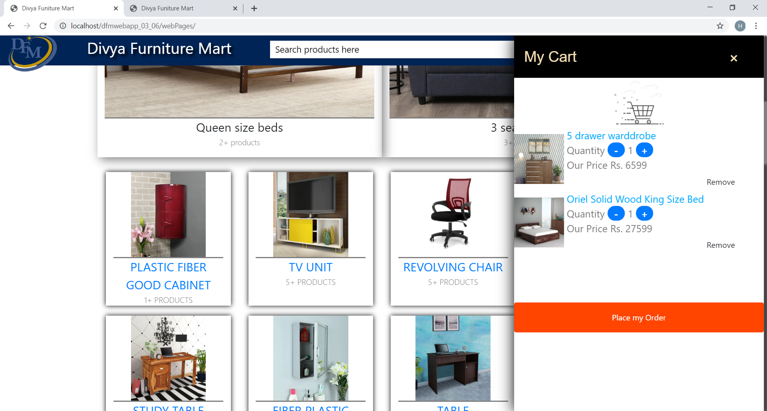

Fig 5.4.1 Empty Cart Fig 5.4.1 Products in Cart

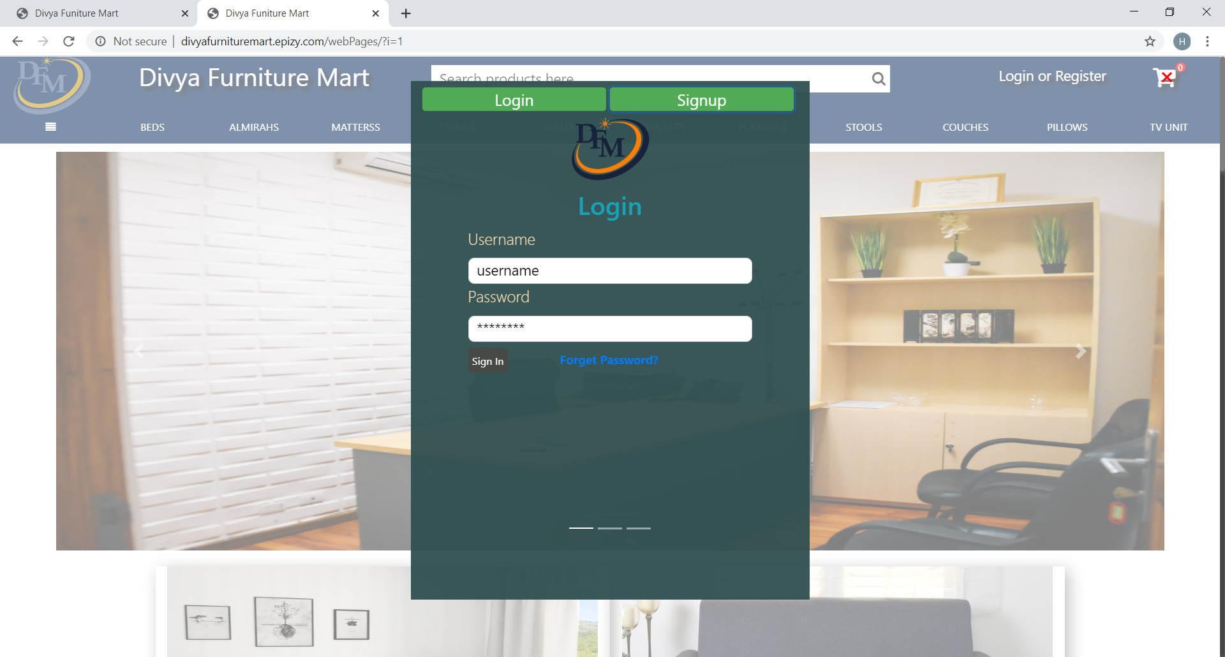 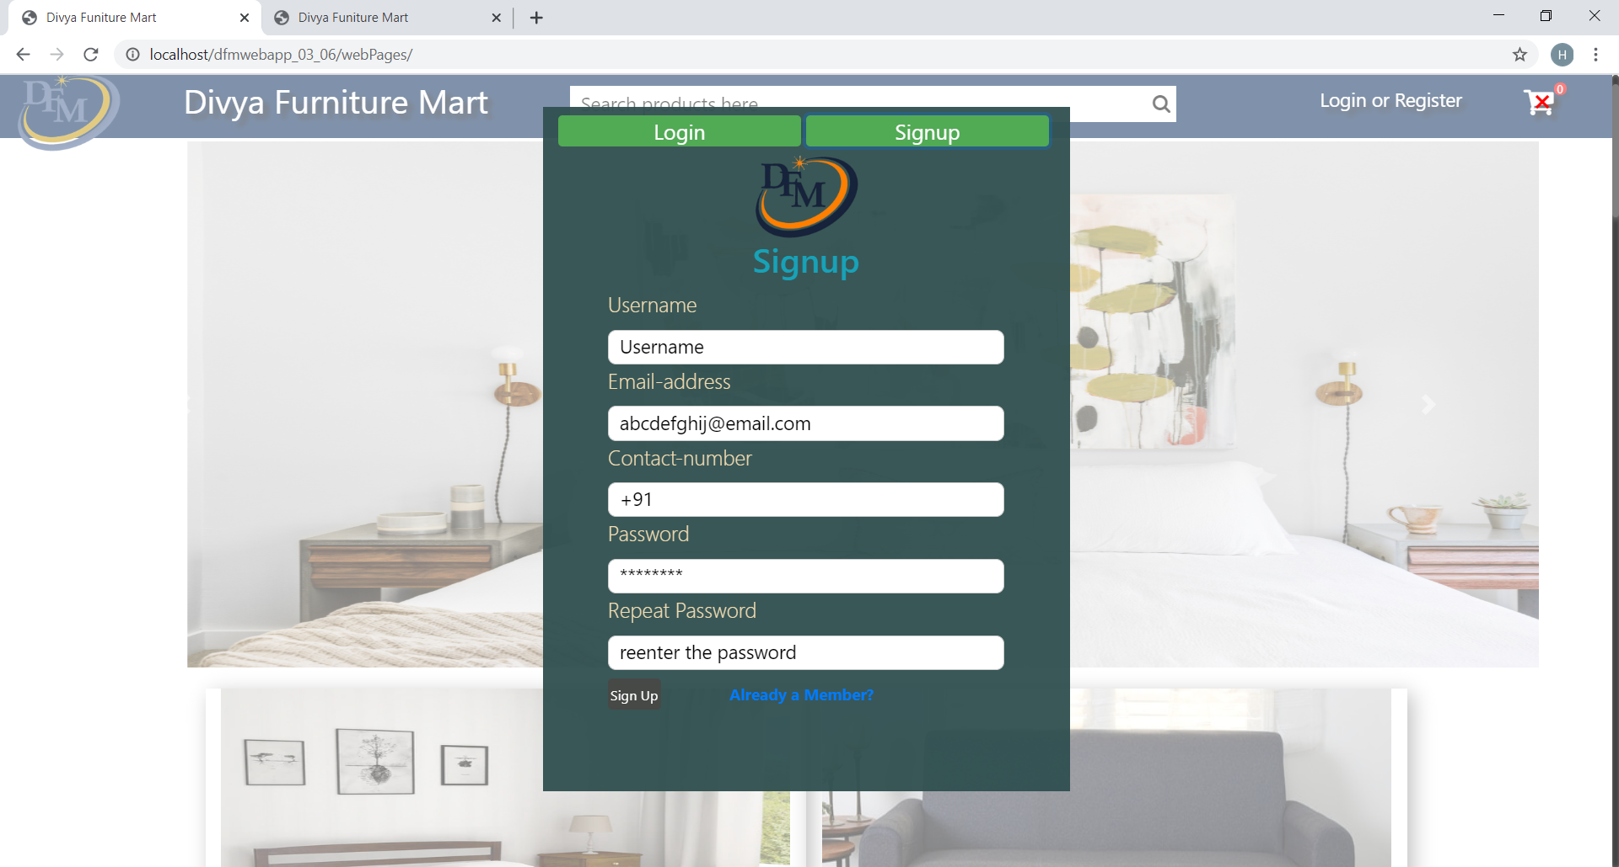

Fig 5.5.1 Login Fig 5.5.2 SignUp

 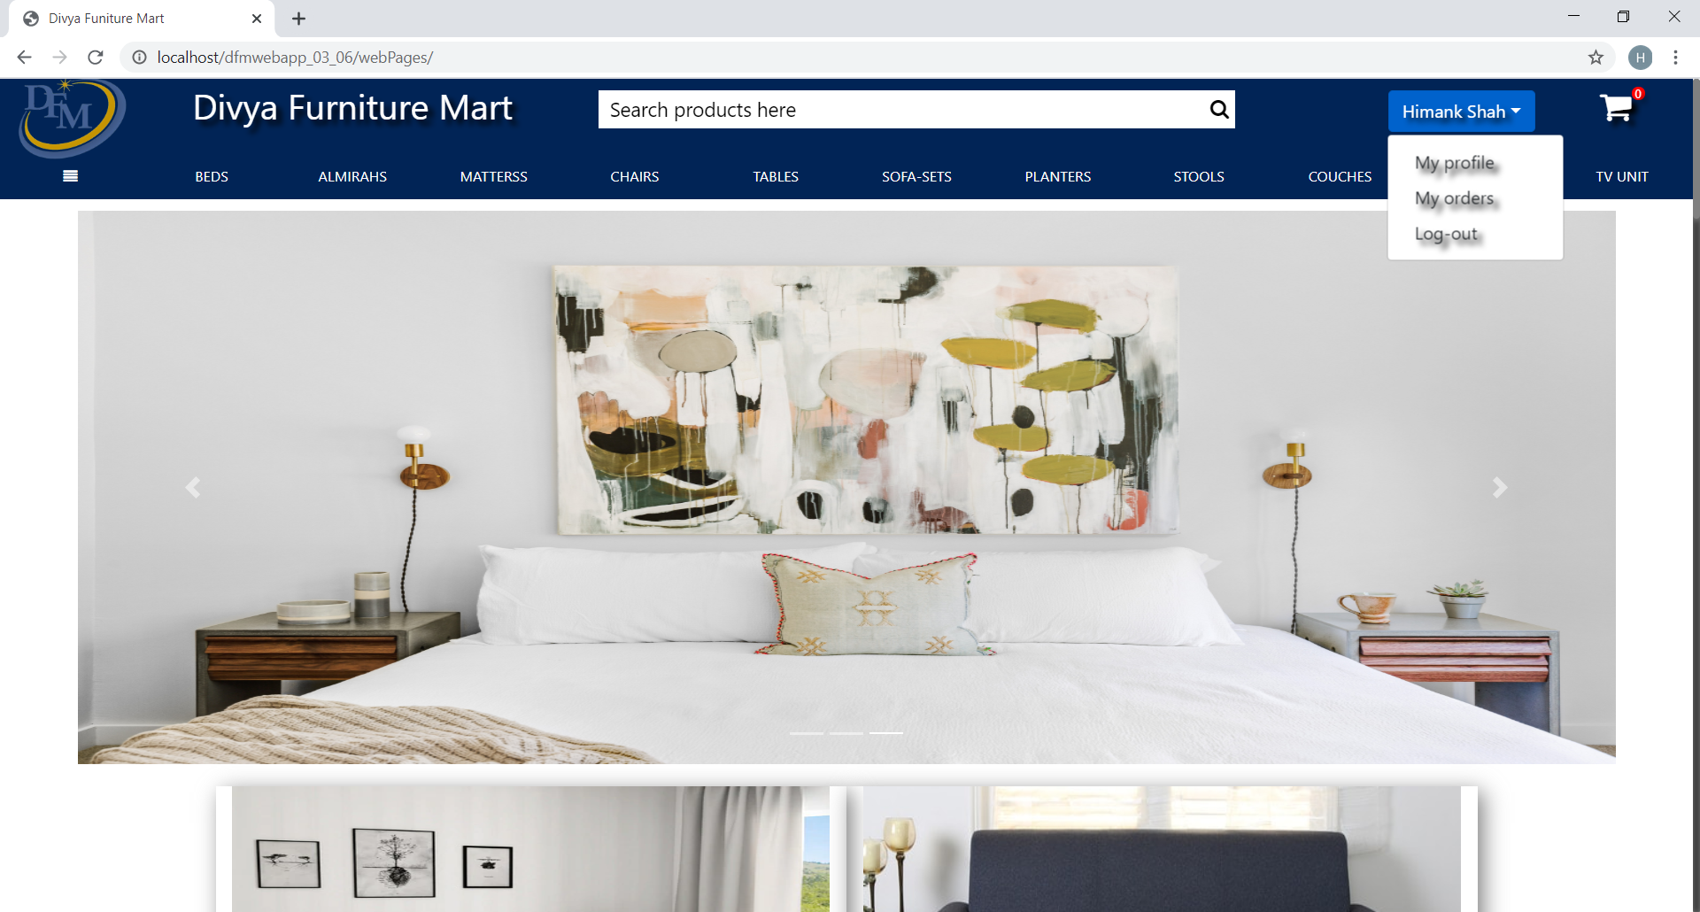

Fig 5.6.1 User Not Login Fig 5.6.2 User Login

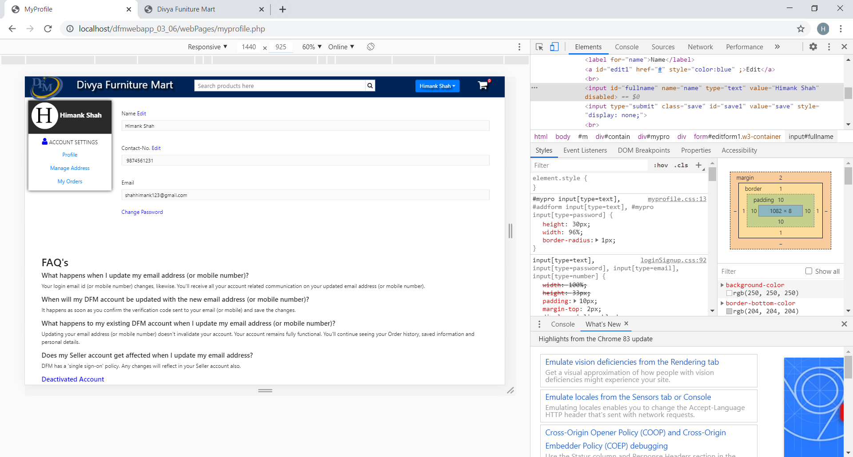

Fig 5.7 User Profile

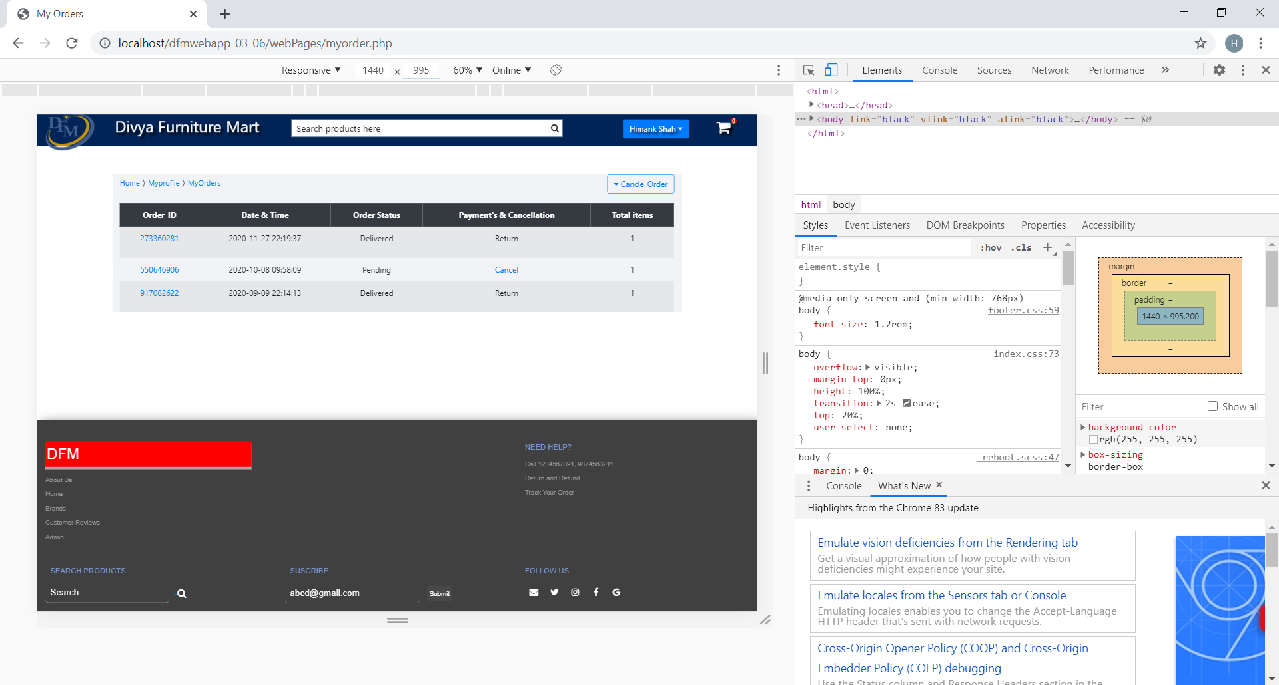

Fig 5.8 User Orders

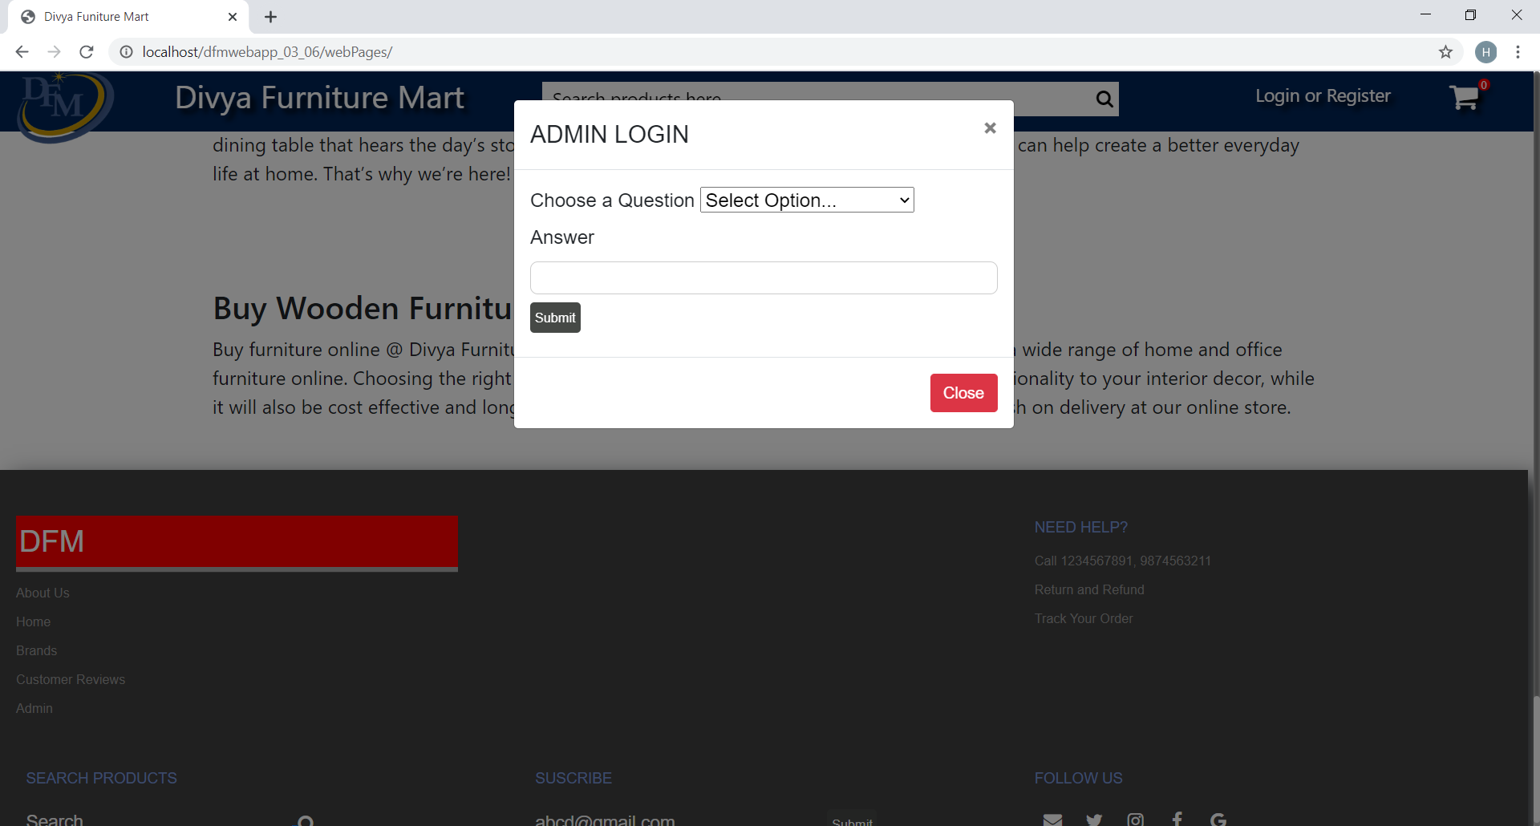

Fig 5.9 Admin Login

**Futurey Scope of App**

In feature version of app, we can enhance, improve and update the following features in our DFM Web App which will make our application more efficient and user effective then now features can be added in future are:

* We add the feature of the wish list in the system for users.
* We add the customable size option for the user so that user can by product of their own choice and size.
* We will try to give the option of multiple color, size and option.
* We also try to add the 3D looks of the products so that user see the products easily.

**Conclusion**

We have successfully implemented the site ‘DFM Web App’. With the help of various links and tools, we have been soon able to provide a site which will be live soon and running on the web. We have been successful in our attempt to take care of the needs of both the users as well as the administrator. Finally, we hope that this will go a long way in popularizing.

The system has been developed with much care and free of errors and at the same time it is efficient and less time consuming. The purpose of this project was to develop a web application for purchasing items from a shop.

This project helped us in gaining valuable information and practical knowledge on several topics like designing web pages using html & CSS, usage of responsive templates, designing of android applications, and management of database using MySQL. The entire system is secured.

Also, the project helped us understanding about the development phases of a project and software development life cycle. We learned how to test different features of a project. This project has given us great satisfaction in having designed an application which can be implemented to any nearby shops or branded shops selling various kinds of products by simple modifications.

**Bibliography and Reference**

8.1 Reference Books

* Fundamentals of Database systems – Elmasri and Navathe.
* HTML by Herbert Schildt.
* Web Programming by Chris Bates.

8.2 Other Documents and Resources

* <https://www.w3schools.com/html/>
* <https://www.w3schools.com/js/default.asp>
* <https://www.w3schools.com/php/default.asp>
* <https://www.w3schools.com/bootstrap/bootstrap_ver.asp>
* <https://www.w3schools.com/w3css/default.asp>
* <https://www.w3schools.com/css/default.asp>